
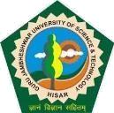
TRAINING & PLACEMENT CELL

Guru Jambheshwar University of Science & Technology, Hisar, Haryana-125 001

(‘A+’ Grade NAAC Accredited State Govt. University)

(Established by State Legislature Act 17 of 1995)

Ref. No. «Ref_No».
Dated: «Date»
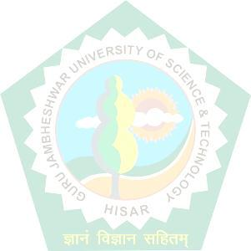
To
«Designation_of_the_person»,
«Company_Name»,

«Company_Location».

Dear Madam / Sir

Greetings from the Training & Placement Cell of GJUS&T, Hisar.`

It is our pleasure to introduce you to Guru Jambheshwar University of Science & Technology, Hisar as one of the prestigious University having "A+" Grade by NAAC in 2022, having been ranked 24th in 2016 and ranked in 101-150 in 2023 among the Universities of India as per National Institute Ranking Framework (NIRF), having been graded autonomy under Category-II by MHRD in 2018 and recently, four B.Tech courses having been accredited by NBA as well. The University has been ranked 321st World’s Most Sustainable University in 2019 in UI Green Matric World Rankings announced by the University of Indonesia, Jakarta. The University has secured 49th rank in the Pharmacy category under NIRF 2023.

Over 25 years of its inception spread in 372 Acres of Lush Green Campus, The University at present, in addition to 24 programs through distance learning mode, offers 71 regular courses including B. Tech. and M.Tech. in Computer Science & Engg., Electronic Communication & Engg., Mechanical Engg., Electrical Engg., Civil Engg., Food Technology, M.B.A, M.Com, M.C.A, M.Sc. in Mass Communication, Applied Psychology, Biotechnology, and Bachelor and Master in Pharmaceutical Science, Physiotherapy etc. with Ph.D. degree program in almost all the streams. We are striving for establishing as a centre of excellence in terms of academic programs and research infrastructure. As a part of curriculum, the student has to undergo a 4 to 6 weeks training program during summer and industrial training program in an organization of repute.

We recommend our student Mr./Ms. «Name» Roll No. «Roll_Number»Mobile Number «Mobile_Number_» of «Class» (Class) «Year» Year to undergo «Duration_» (weeks/months) training in your esteemed organization starting from «Internship_Starting_Date».

We would very much appreciate if the student can be accommodated for the training program. Our students are sincere and hardworking and we are sure that they will put in their best efforts during the training program.

A Line in confirmation will be highly appreciated.

Yours Sincerely

Dr. Pratap Singh Malik
Director (Placement)

STAMP HERE

Contact us

Training & Placement Cell, 1st Floor, PDUIIC, GJUS&T, GJUS&T, Hisar, Haryana

Contact: 01662-263777-507, +91-9868914103,

E-mail: tpcell@gjust.org, (Website: www.tpc.gjuonline.ac.in)

